Suppose that a data warehouse consists of the three dimensions time, doctor, and

patient, and the two measures count and charge, where charge is the fee that a doctor

charges a patient for a visit.

1. Enumerate three classes of schemas that are popularly used for modeling data warehouses.
2. Three classes of schemas popularly used for modeling data warehouses are the star schema, the snowflake schema, and the fact constellations schema.
3. Draw a schema diagram for the above data warehouse using one of the schema classes listed in (a).

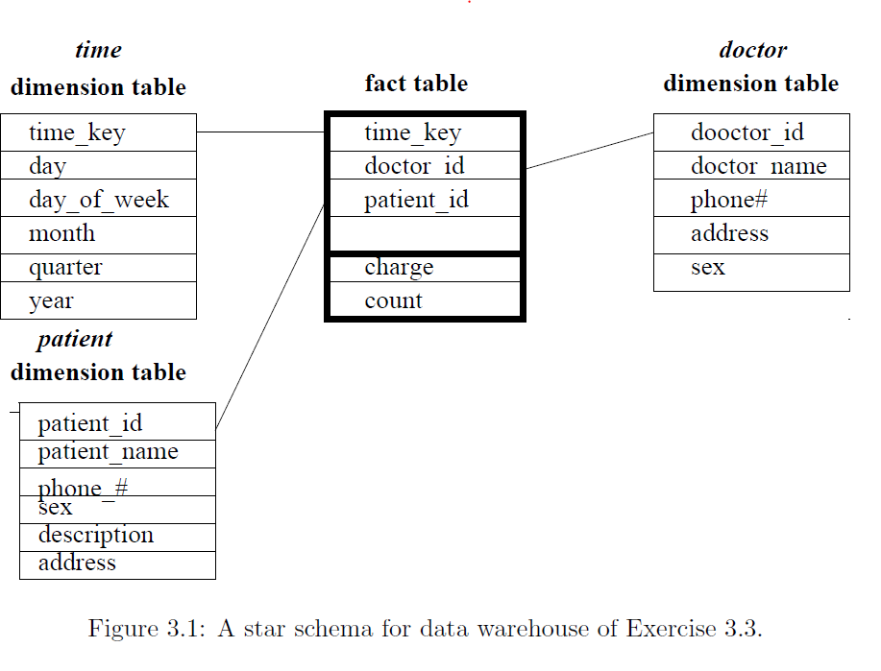

1. Starting with the base cuboid [day, doctor, patient], what specific OLAP operations should be performed in order to list the total fee collected by each doctor in 2004?

Roll-up on *time* from *day* to *year*.

Slice for *time=2004*.

Roll-up on *patient* from individual patient to all.

1. To obtain the same list, write an SQL query assuming the data are stored in a relational database with the schema fee (day, month, year, doctor, hospital, patient, count, charge).

select doctor, SUM(charge)

from fee

where year=2004

group by doctor